LAB EXPERIMENTS-2

NAME: S.G.DEVSACHIN

REG.NO: 192111088

COURSE :THEORY OF COMPUTATION

COURSE CODE: CSA1371

1. AIM:

To design DFA to accept bcaaaaaaaaaaaaaa, bc, and c.

PROCEDURE:

1. Create a new file and select the required file format.
2. Select and implement the required number of states and specify its initial and final state.
3. Connect the adjacent states to show the transitions.
4. Specify the input symbol,output symbol and head movements for each state.
5. Give the inputs and execute the file by clicking on the simulate automata button and check whether the required output is being obtained.

OUTPUT: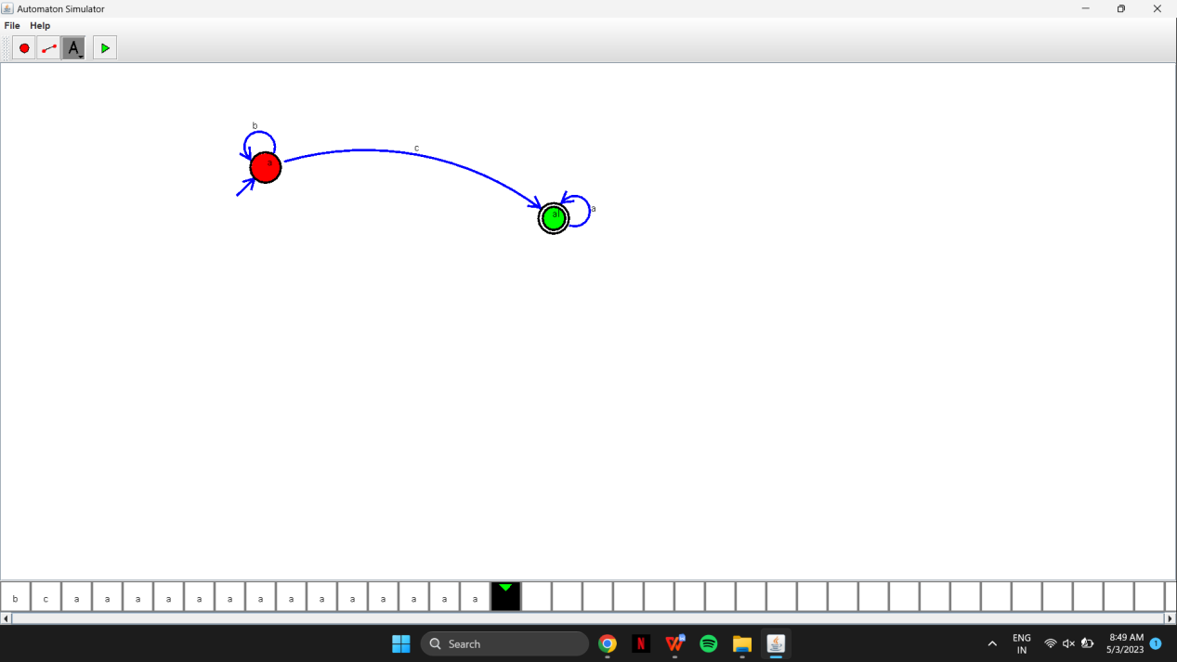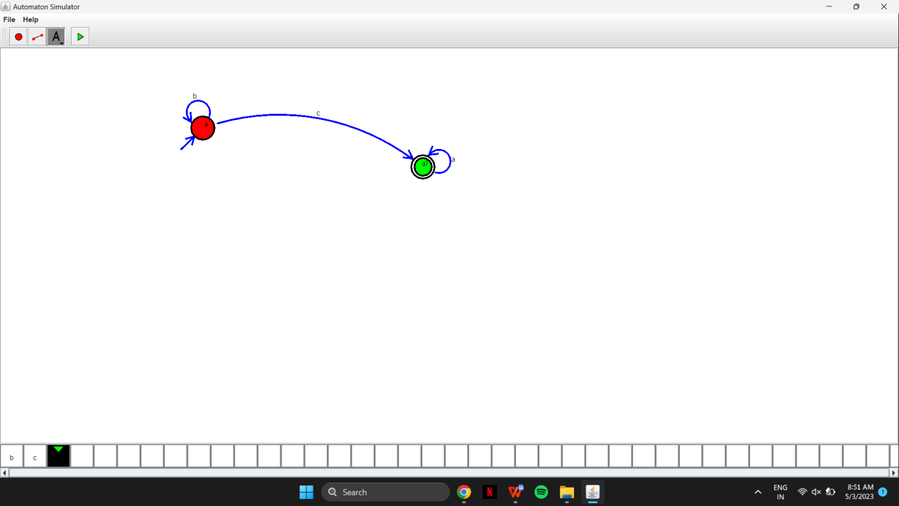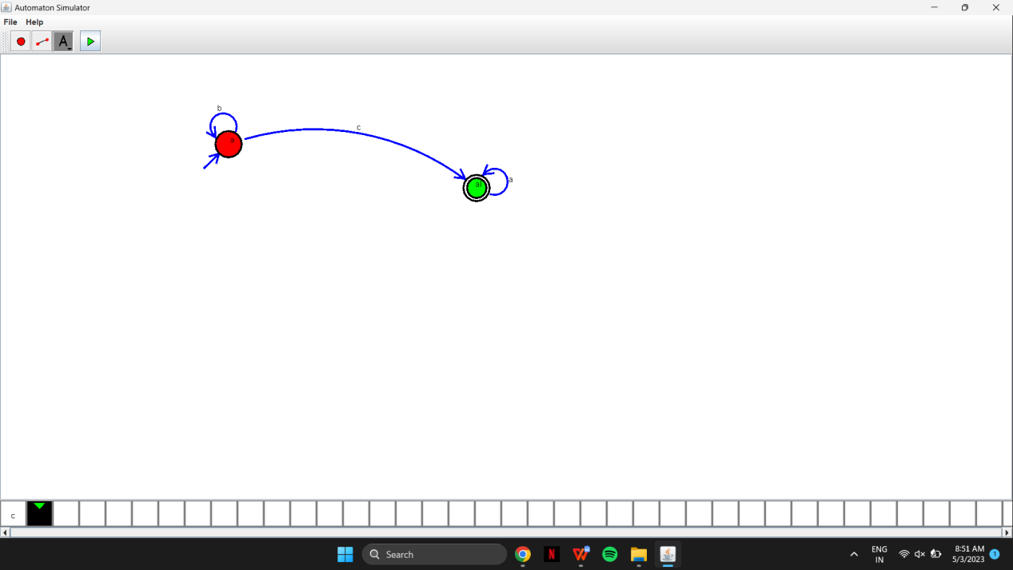

RESULT:

The required design has been constructed and executed successfully.

1. AIM:

Design NFA to accept aaaaaa.

PROCEDURE:

1. Create a new file and select the required file format.
2. Select and implement the required number of states and specify its initial and final state.
3. Connect the adjacent states to show the transitions.
4. Specify the input symbol,output symbol and head movements for each state.
5. Give the inputs and execute the file by clicking on the simulate automata button and check whether the required output is being obtained.

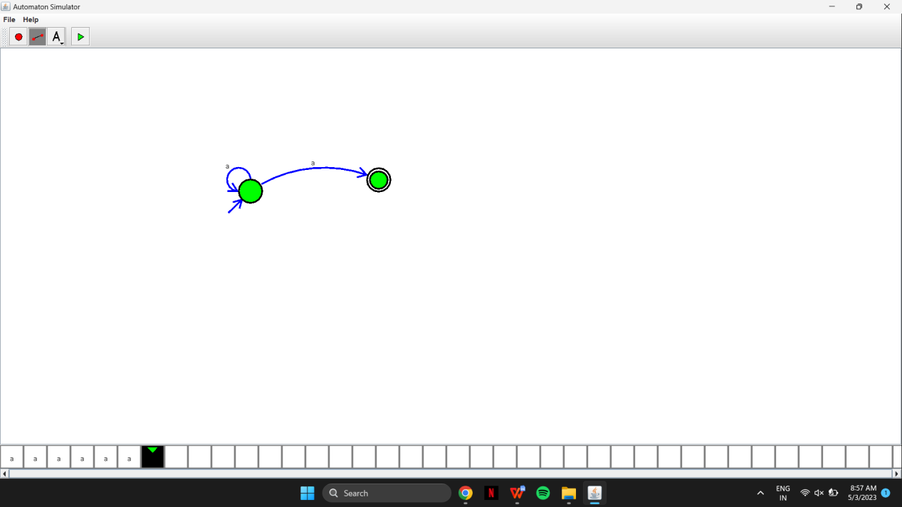

RESULT:

The required design has been constructed and executed successfully.

1. AIM:

Design PDA for the input a^nb^n.

PROCEDURE:

1. Create a new file and select the required file format.
2. Select and implement the required number of states and specify its initial and final state.
3. Connect the adjacent states to show the transitions.
4. Specify the input symbol,output symbol and head movements for each state.
5. Give the inputs and execute the file by clicking on the simulate automata button and check whether the required output is being obtained.

OUTPUT:

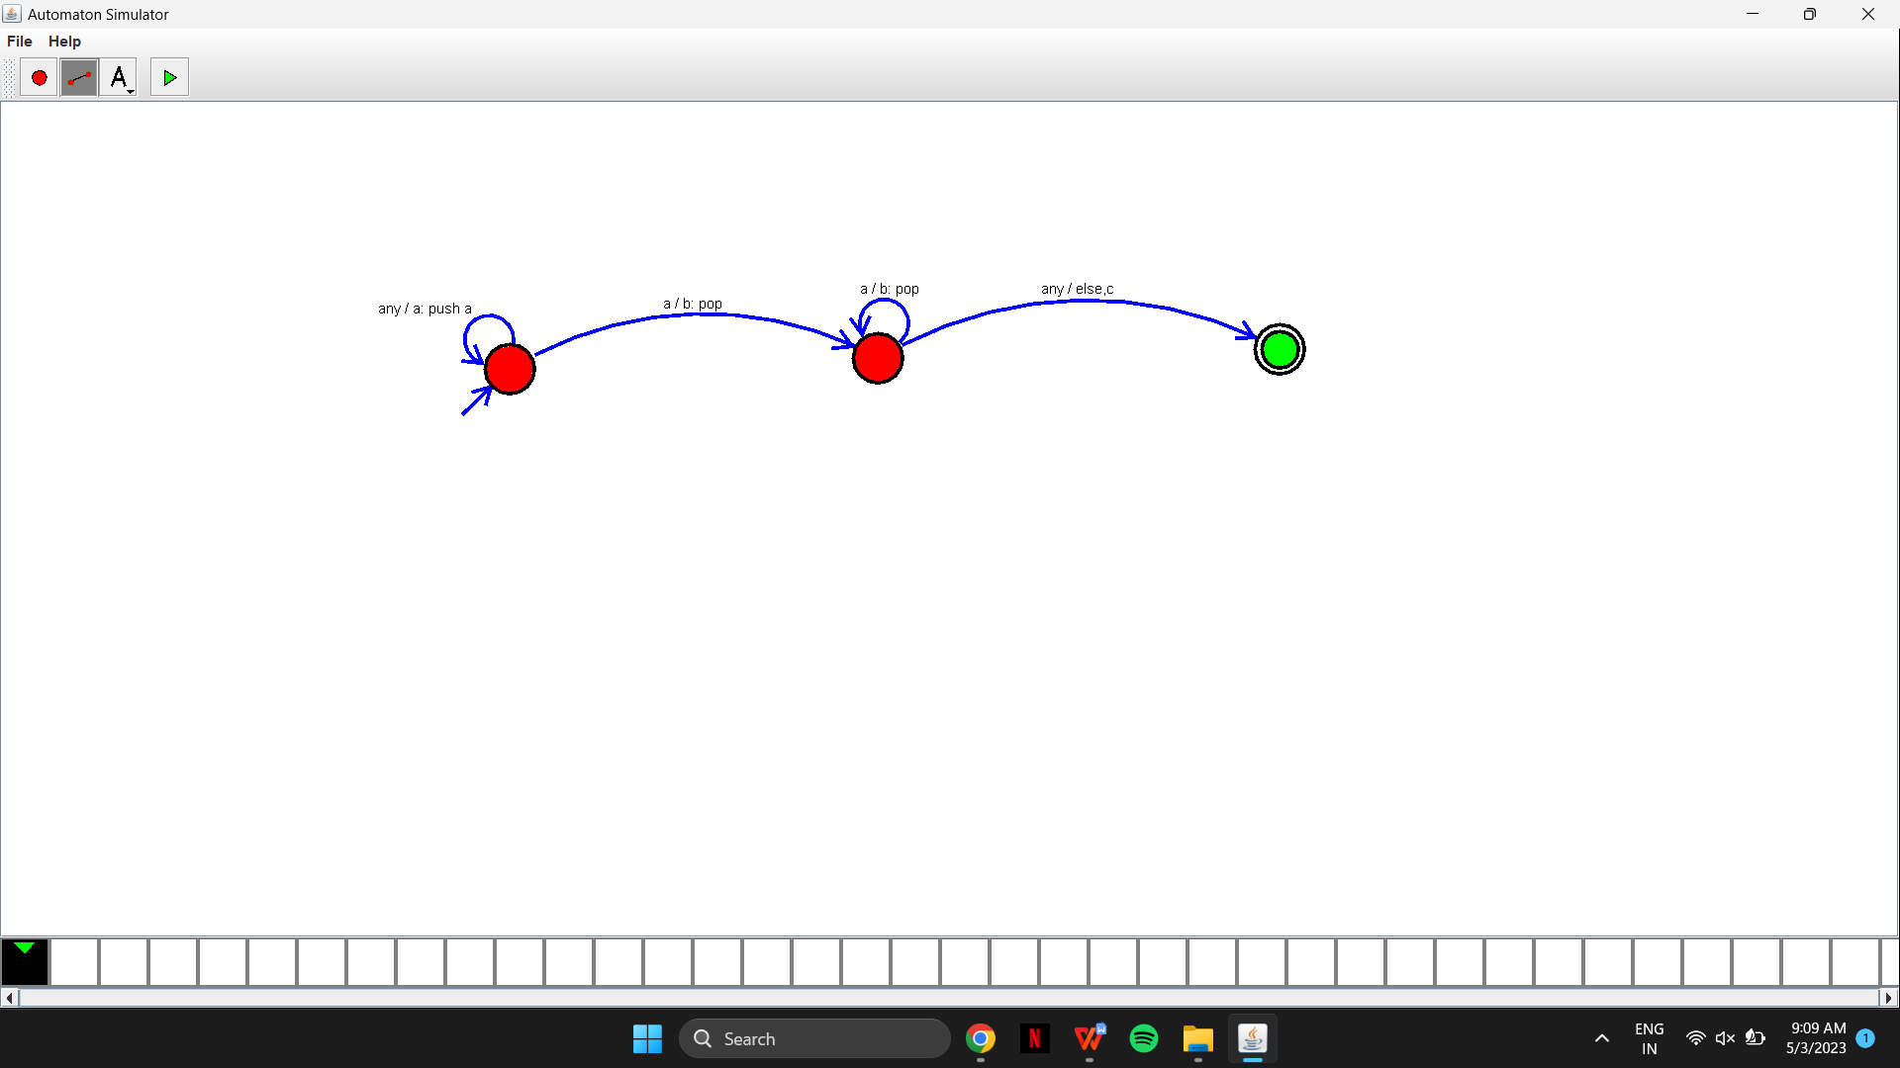

1. AIM:

Design Tm For input a^nb^n.

PROCEDURE:

1. Create a new file and select the required file format.
2. Select and implement the required number of states and specify its initial and final state.
3. Connect the adjacent states to show the transitions.
4. Specify the input symbol,output symbol and head movements for each state.
5. Give the inputs and execute the file by clicking on the simulate automata button and check whether the required output is being obtained.

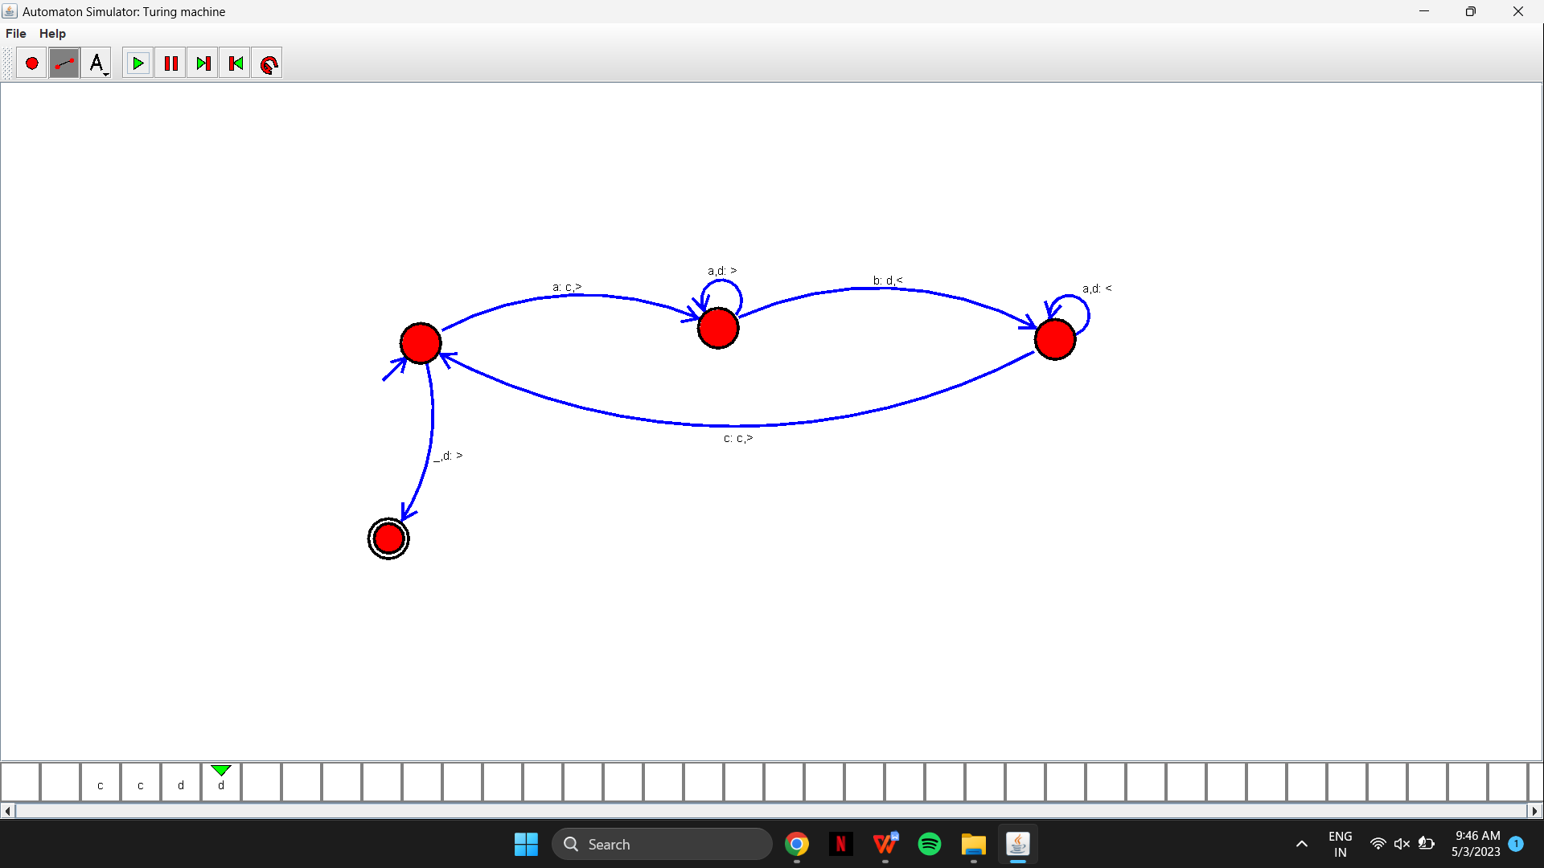

RESULT:

The required design has been constructed and executed successfully.

1. AIM:

Design PDA for input aabbbbc ( L=a^nb^2n)

PROCEDURE:

1. Create a new file and select the required file format.
2. Select and implement the required number of states and specify its initial and final state.
3. Connect the adjacent states to show the transitions.
4. Specify the input symbol,output symbol and head movements for each state.
5. Give the inputs and execute the file by clicking on the simulate automata button and check whether the required output is being obtained.

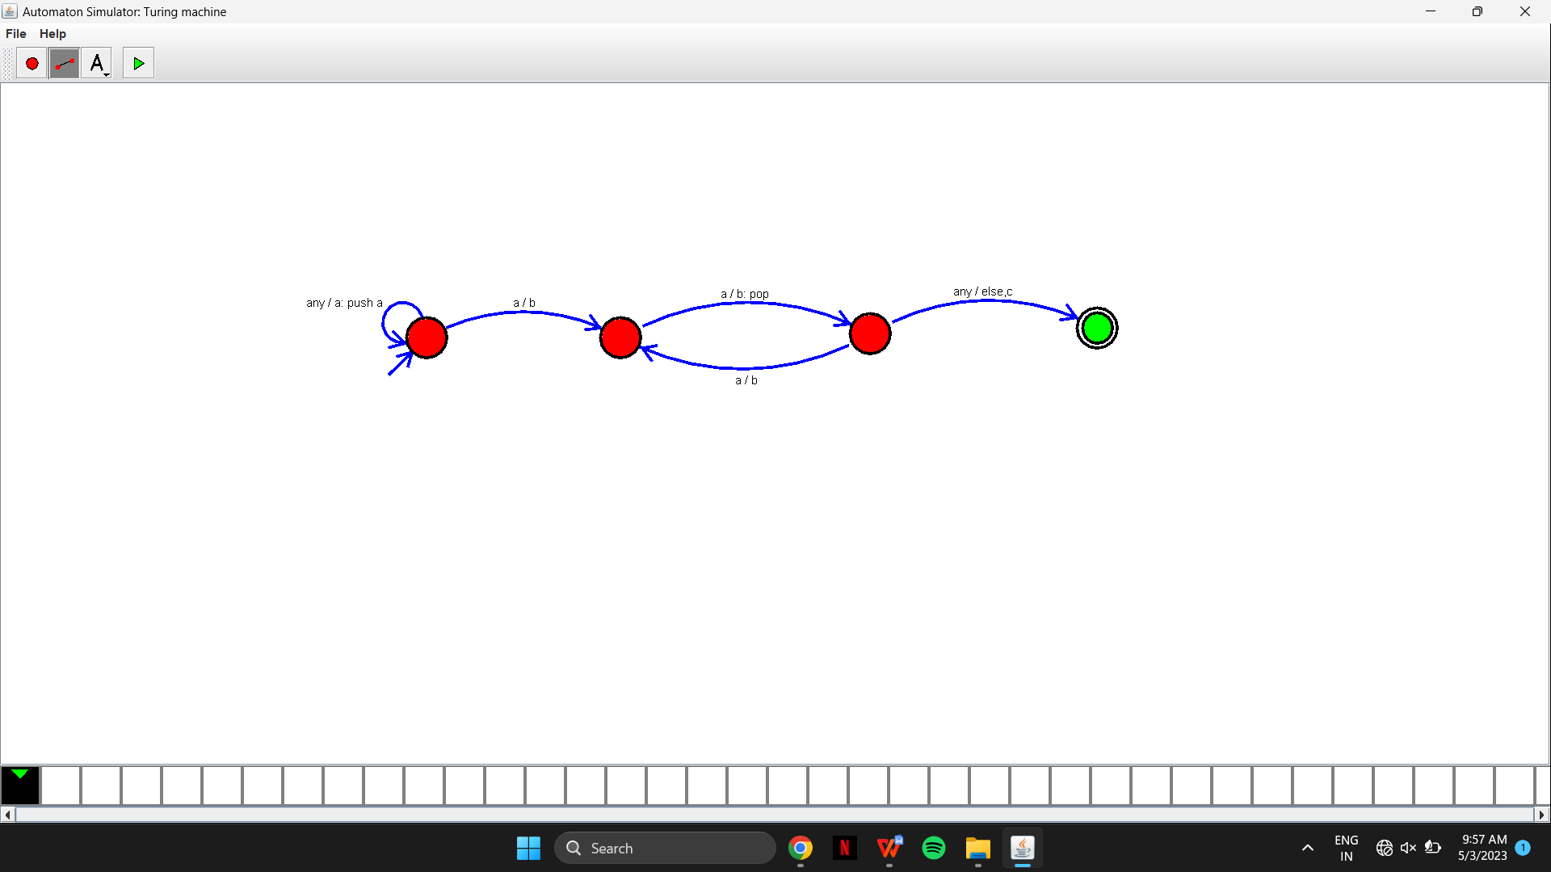

RESULT:

The required design has been constructed and executed successfully.

1. AIM:

TM Simulation for Palindrome W= ababa c

PROCEDURE:

1. Create a new file and select the required file format.
2. Select and implement the required number of states and specify its initial and final state.
3. Connect the adjacent states to show the transitions.
4. Specify the input symbol,output symbol and head movements for each state.
5. Give the inputs and execute the file by clicking on the simulate automata button and check whether the required output is being obtained.

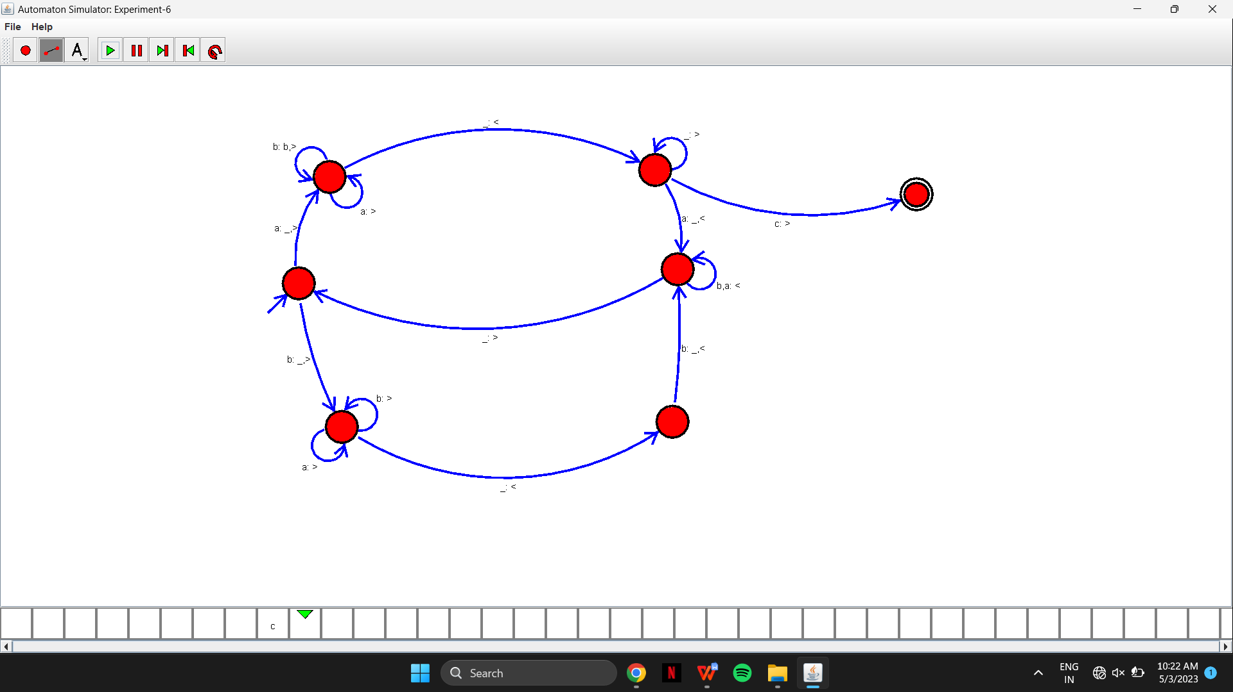

RESULT:

The required design has been constructed and executed successfully.

1. AIM:

Design TM to perform addition of following

W= aa + aaaa

After Addition of a’s = aaaaaa

PROCEDURE:

1. Create a new file and select the required file format.
2. Select and implement the required number of states and specify its initial and final state.
3. Connect the adjacent states to show the transitions.
4. Specify the input symbol,output symbol and head movements for each state.
5. Give the inputs and execute the file by clicking on the simulate automata button and check whether the required output is being obtained.

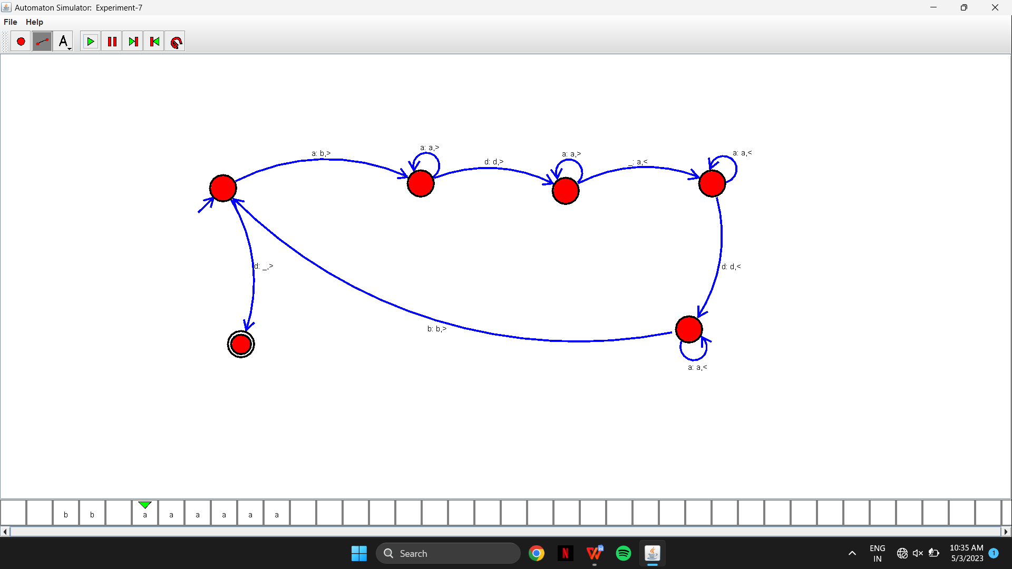

RESULT:

The required design has been constructed and executed successfully.

1. AIM:

Design TM to perform subtraction

W= aaa-aa

The Result of Subtraction is = a.

PROCEDURE:

1. Create a new file and select the required file format.
2. Select and implement the required number of states and specify its initial and final state.
3. Connect the adjacent states to show the transitions.
4. Specify the input symbol,output symbol and head movements for each state.
5. Give the inputs and execute the file by clicking on the simulate automata button and check whether the required output is being obtained.

OUTPUT

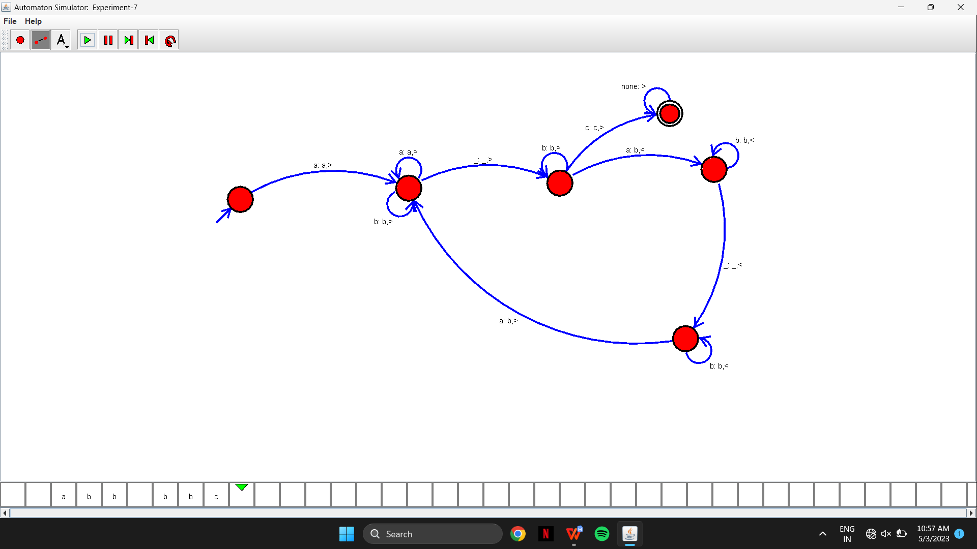

RESULT:

The required design has been constructed and executed successfully

1. AIM:

Design TM to perform string comparison

W = aba aba

PROCEDURE:

1. Create a new file and select the required file format.
2. Select and implement the required number of states and specify its initial and final state.
3. Connect the adjacent states to show the transitions.
4. Specify the input symbol,output symbol and head movements for each state.
5. Give the inputs and execute the file by clicking on the simulate automata button and check whether the required output is being obtained.

OUTPUT:

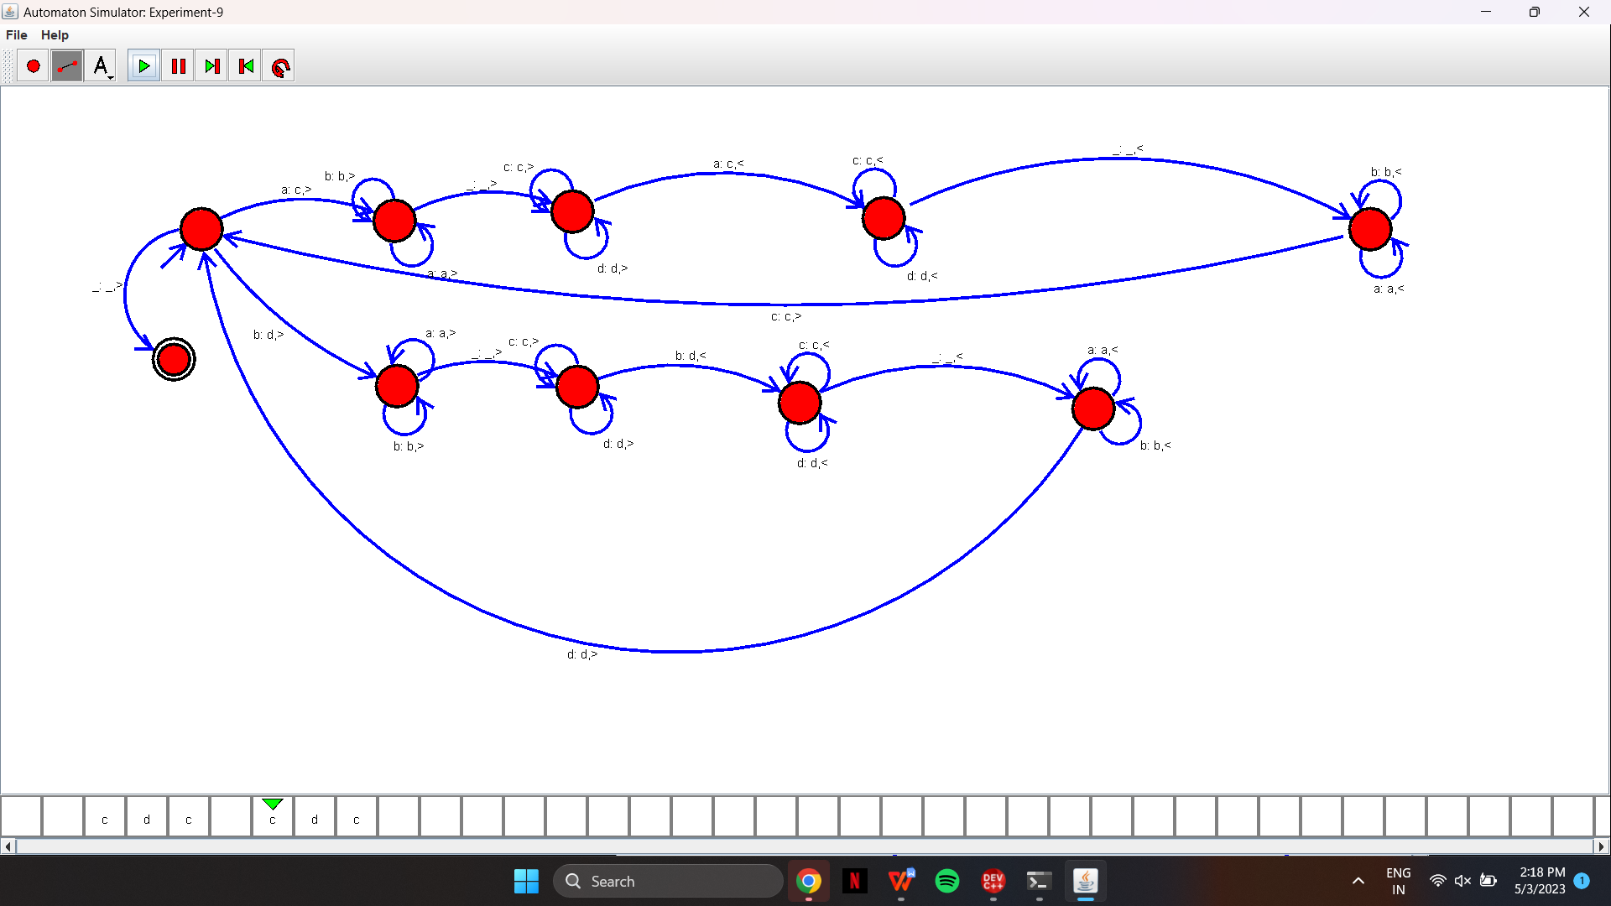

RESULT:

The required design has been constructed and executed successfully.